17.69: From Eq. 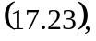 the energy that flows in time is

